# General instruction for preparing the climatic file

* The model run on hourly basis.
* One could input hourly climatic data or let the model to calculate the hourly climatic data itself. Thus one need to specify the Boolean variable inputEnvironmentCondition = false or true.
* The model can calculate hourly climatic data based on day of year, maximum and minimum temperature and humidity through a sin interpolation.
* Climatic file are stored as csv files.
* DayOfYear, hourOfDay, Temp, RH, total.radiation.umol.m2.s, CO2.ppm, wind.m.s, soil water potential.MPa or soil water content are needed for the model input. More columns can be added in the climatic data file, but will not be used in the model for the moment.

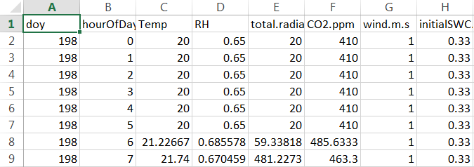

* Column names does not matter but the sequence need to be fixed.
* In the scenario file and the model input data list.xlsx, one need to specify he or she will input soil water potential.MPa or soil water content by the variable of input_SWC_OR_SWPsi
* The value for one o’clock means the average climatic condition between 0 o’clock to 1 o’clock.
* For consistence, the climatic condition for 24 o’clock was noted as 0 o’clock. The model use the query that hour equal to 0 o’clock for increase the day count.